Criteria 3 - Collecting data about the need or opportunity

**Instructions**

Students are required to document data for analysis using appropriate data collection methods. The data collected will contribute to the use of analytical tools and techniques in Criterion 3 and the development of a software requirements specification in Criterion 4. The process of data collection may involve students communicating back-and-forth with their clients.

Students will document evidence of their critical and creative thinking through the identification, clarification and critical analysis of the data collected as part of the Analysis Stage in Criterion 3.

**Evidence**

A table that describes the data collected, the method used and justifies the choice of method for that data.

Evidence of your understanding of the relationship between data, users and digital systems through the use of the four graphical representations.

3.1 Data Collected and Justification

**Instructions**

You need to collect more data about the need or opportunity you identified in your *project proposal*.

Describe the data collected, the method used to collect it (survey, interview, report, observation etc.) and justify its use. The justification should include the pros and cons of the selected method and critical analysis of data’s lineage.

A copy of all data collection tool(s) and record of data collected should be included as part of the Appendix.

|  |  |  |  |
| --- | --- | --- | --- |
| **Data Needed** | **Data Source(s)** | **Collection Method** | **Reflection on the process** |
| Scope, restrictions, functional and non-functional constraints. | Client | **Interview** | To have a detailed idea of what the client is requesting for and collect data on the area’s information is needed |
| Layout, draft ideas, possible option to add | Vermont SC Main entrance login system. | **Observation** | To observe and get a better understanding of the organization and note certain details that are important to the solution |
| Number and basic data (number of staff) | Client | Survey | To get small bits of info to get the basic data |

3.2 Graphical representations of the relationship between data, users and digital systems

**Instructions**

From your research and data, you need to illustrate the relationships between data, users and digital systems using the five common analytical tools:

* Context Diagram
* Data Flow Diagram
* Use Cases
* Use Case Diagrams using UML

3.2.1 Context Diagram

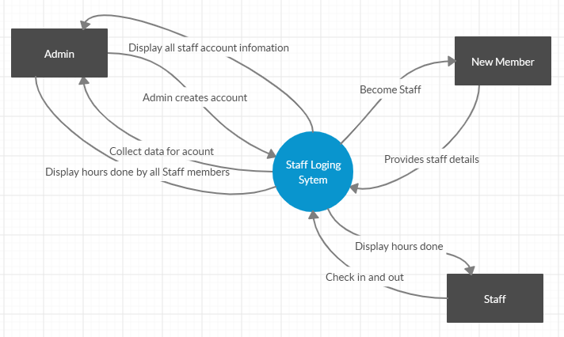

*The context diagram focuses on the interaction of multiple entities and the system in the middle. The focus point being the system is the Childcare center, and entities being the part-time staff, full-time staff, and admin. When a staff member first creates an account a admin will have to create it for them inputting all necessary data like first, last name and if they are full or part time staff into the system. The Staff members will then be able to log in twice a day to check in and out of work. Anytime during the week, the admin and staff will be able to view the number of hours done.*

3.2.2 Data Flow Diagram

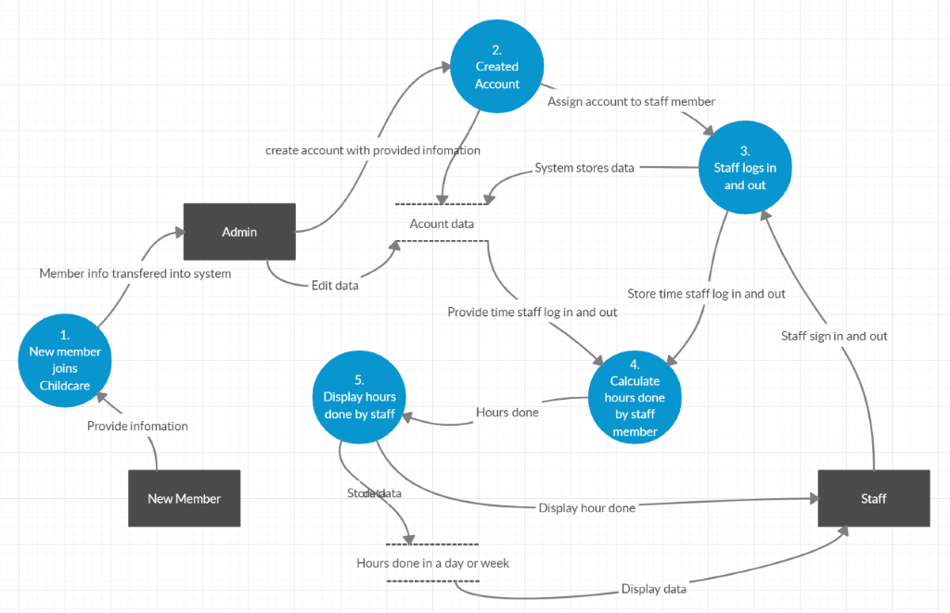

*The data flow diagram will track the data that goes in and out of the system and the prosses it must take. When a staff member joins the childcare center the information of staff member is taken into the system then back out as data by the admin to create an account for the staff member. This account can then be used to track hours done by staff members. When a staff member comes in for the day, They log into the system indicating they have arrived for the day and again later when they have left for the day. The hours will then be recorded based on the amount done for that day. An admin or staff member will then be able to access their account to see hours done, admins will also be able to see all other staff member hours.*

3.2.3 Use Cases

|  |  |  |
| --- | --- | --- |
| **No.** | **Use Case** | **Notes** |
| UC1 | Create account | Account is created by admin |
| UC2 | Assign account | Account is assigned to the New member by a admin |
| US3 | Log in and out | Staff log in and out of work |
| US4 | Edit account | Admin can edit accounts to make any necessary changes |
| US5 | Calculate hours done | System calculates hours done by staff |
| US6 | Provide account information | New member provides information for account |
| US7 | Receive hours done | The information displayed after the computer has done the calculations |
| US8 | Receive account | New member receives account becoming a staff member |

3.2.4 Use case Diagram using UML

